**EC2 Assignment**

**EC2 Task 1**

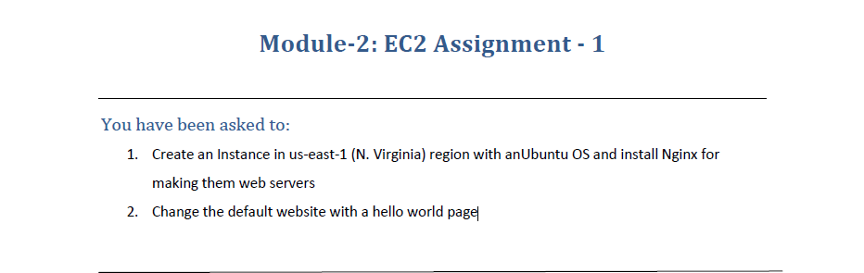

1. Created an Instance with Ubuntu OS on t2.micro in North Virginia Region.

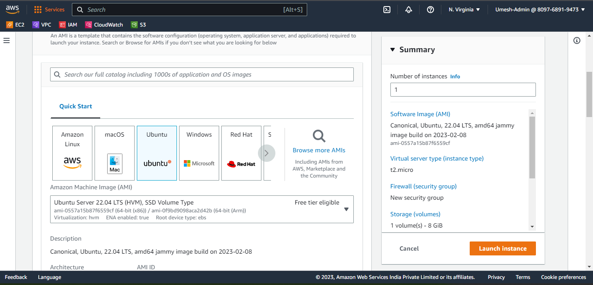

1. Commands used after Connecting to the Instance :
2. sudo apt-get update : Updates the ubuntu OS with any available updates.
3. sudo apt-get install –y nginx : Installs the nginx Package on the Instance.
4. sudo nano /var/www/html/index.html : Creates index.html inside var/www/html (Default directory for Index Page)

Index.html Content :

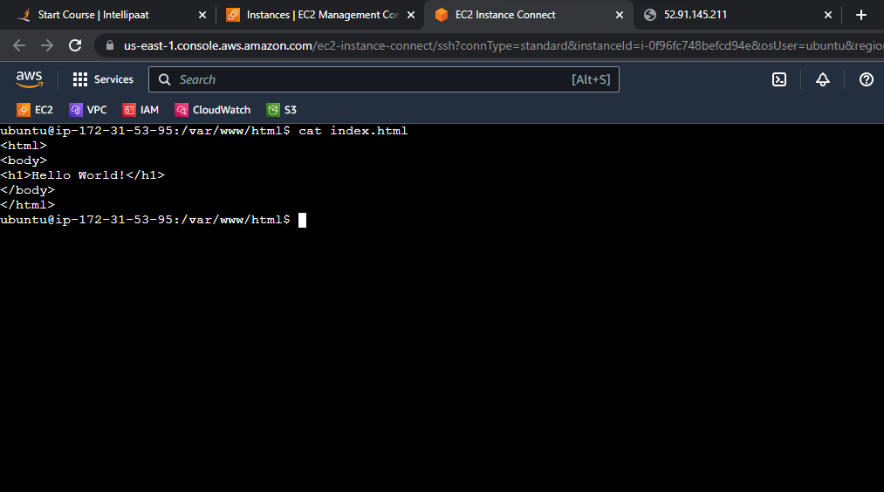

Output after Installing NGINX :

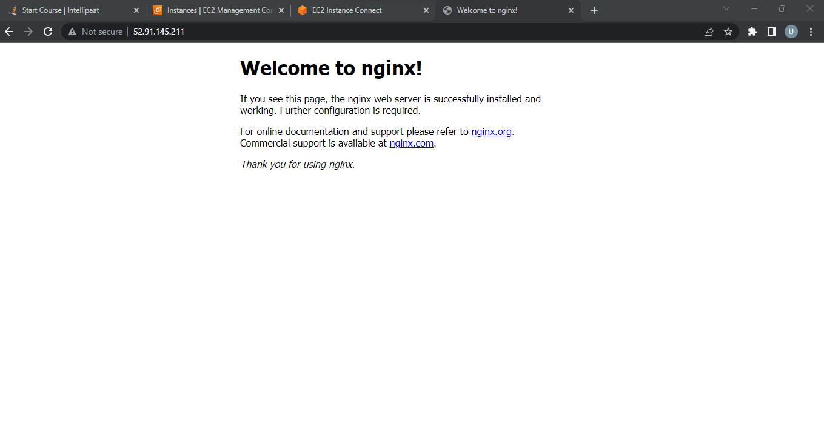

Output after Creating the index.html :

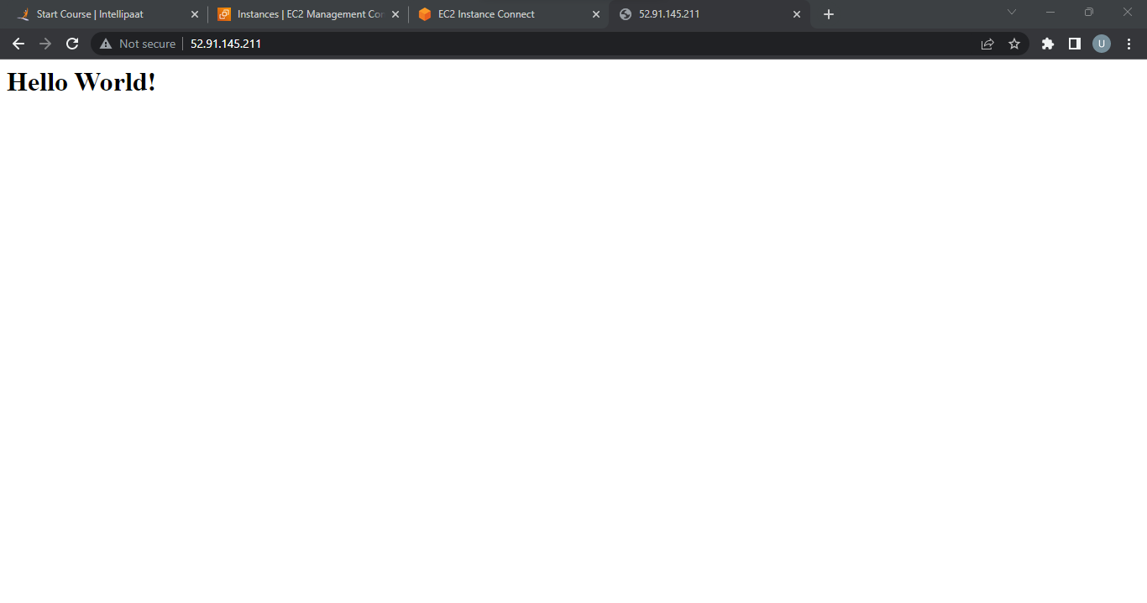

**EC2 Task 2**

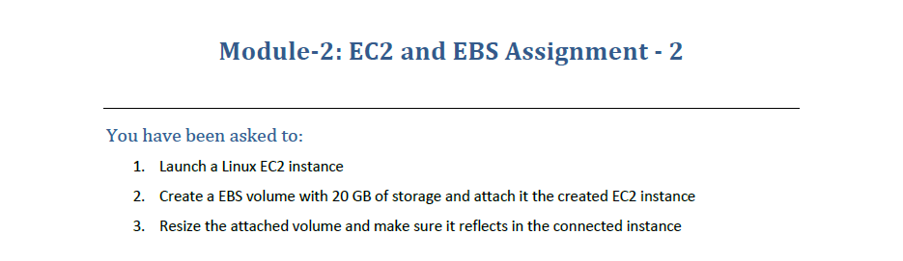

1. Created an Instance with Linux OS and note down the Availability Zone of the Instance (us-east1e in my case).

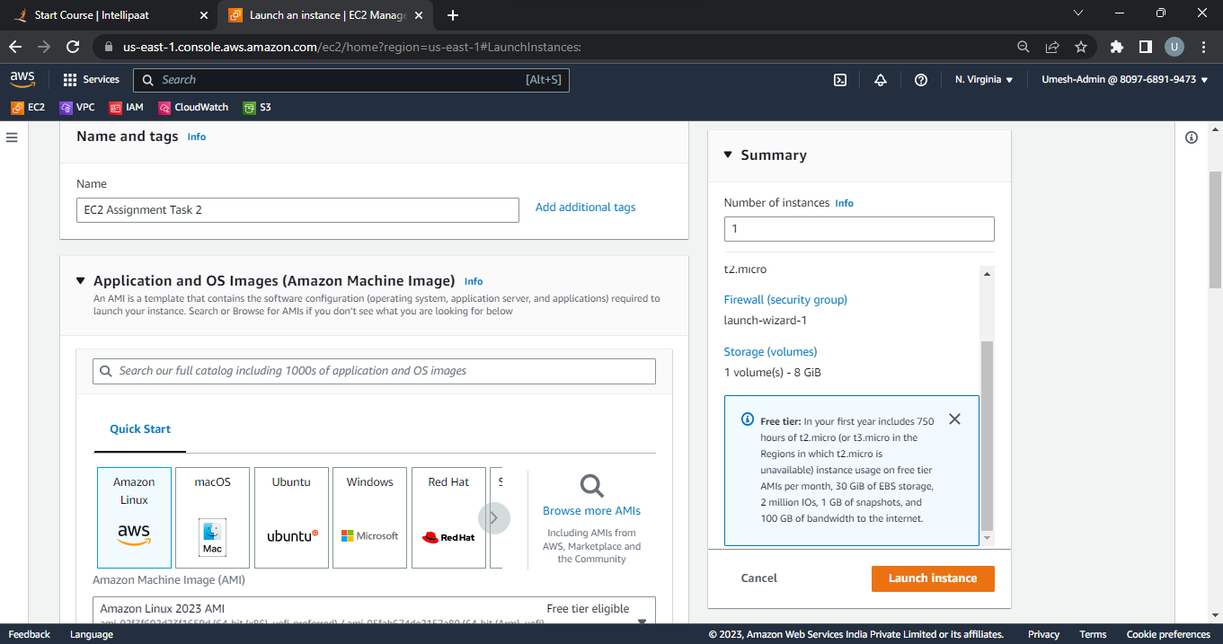

1. Creating EBS Volume of 20GB and Attaching to the Instance.
2. Click on Create Volume Button inside Elastic Block Storage.

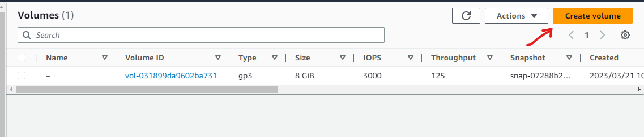

1. Configure the Size Parameter to 20 GB and change the Availability Zone to us-east1e, leave the rest of the setting on default.

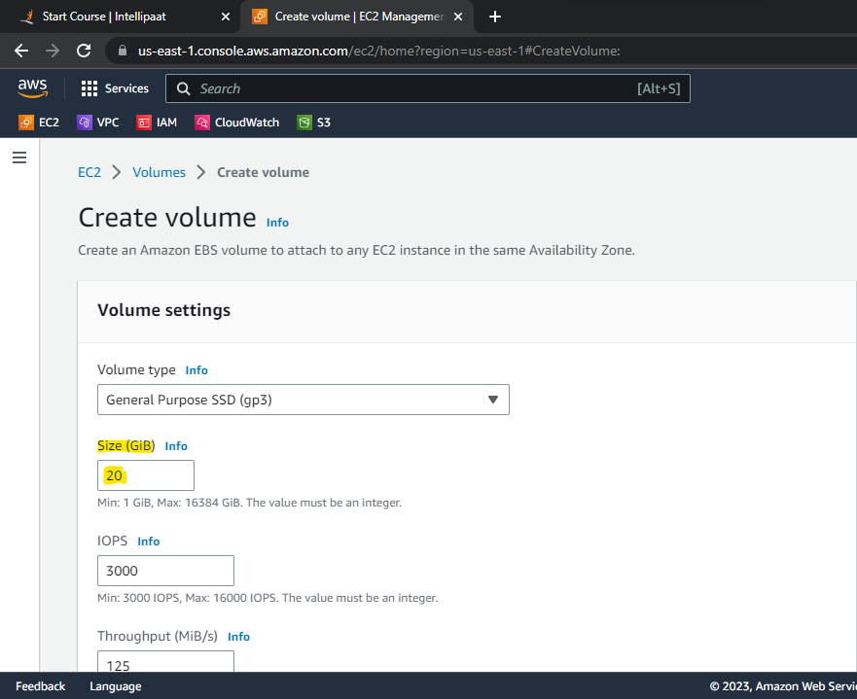

1. Once the Volume State is in Available State, select the Volume and click on Actions > Attach Volume.

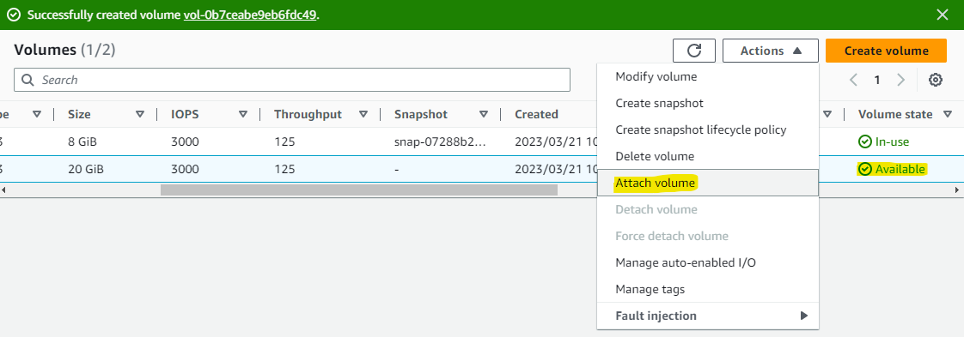

1. Choose the Instance to Attach the EBS Volume.

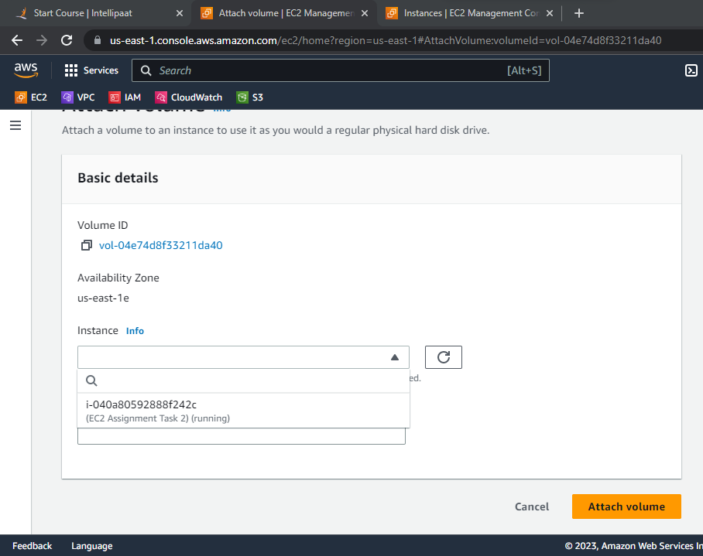

1. Check in Instances, under Storage 2 EBS Storage will be reflected (8gb root and 20gb additional storage)

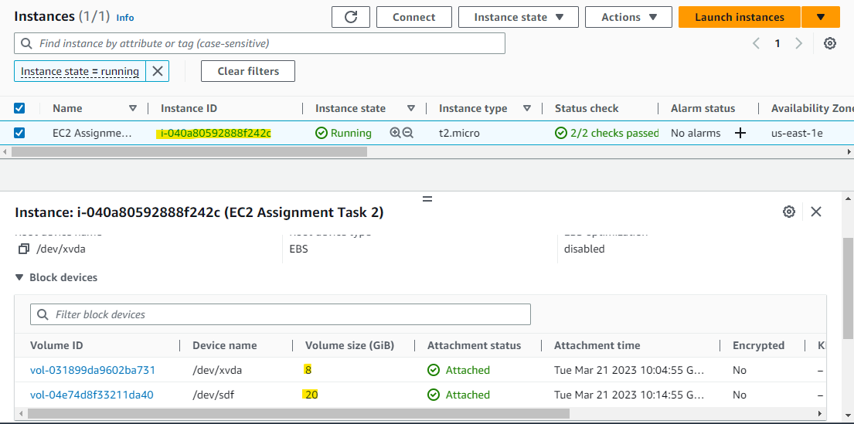

1. Resizing the Attached Volume of 20gb.
2. Select the Storage to Resize. Go to Actions > Modify Volume.

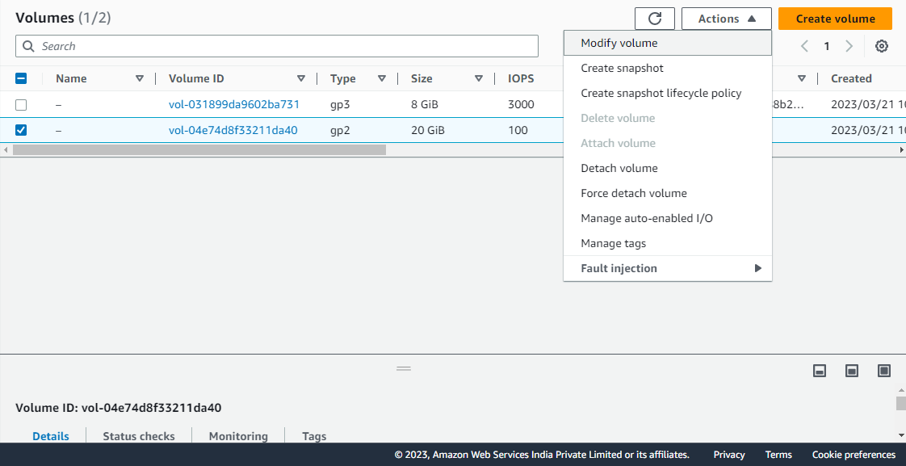

1. Resize the Storage (Note: We can only Increase the Storage.)

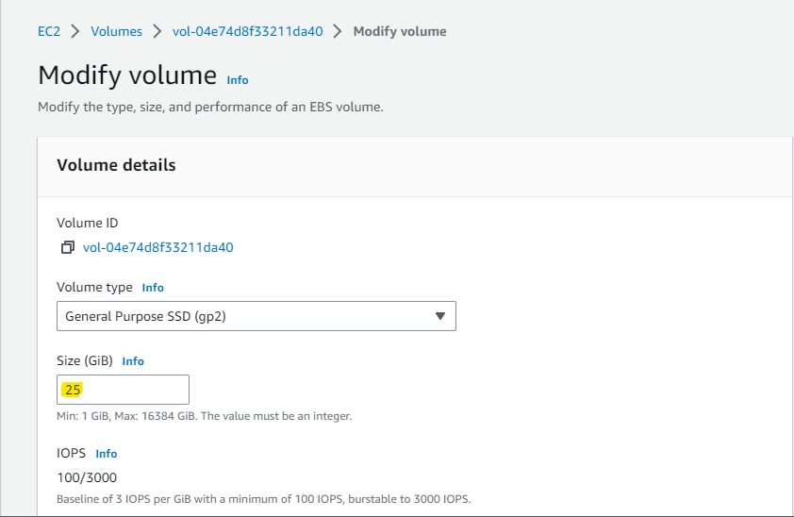

1. Once modified, verify if it reflects in the Instance by going into Instance > Storage.

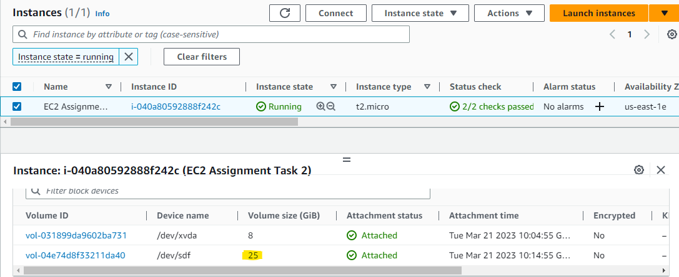

**EC2 Assignment Task 3**

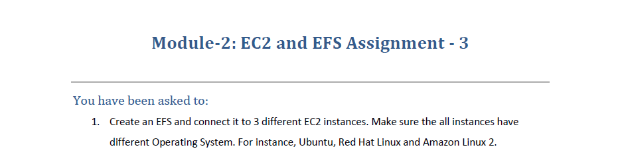

1. Create EFS.

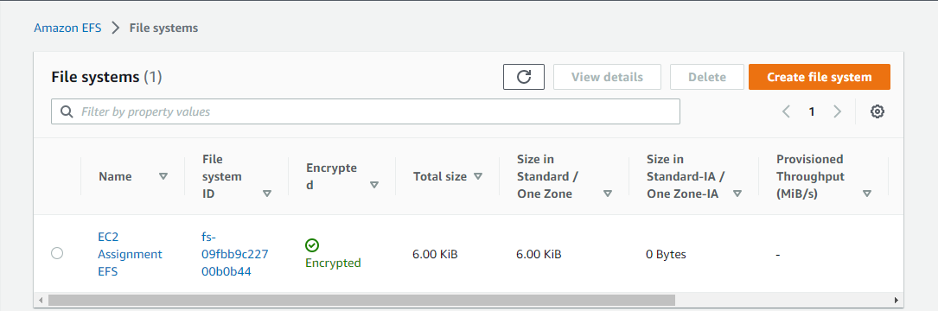

1. Launching 3 Different Instances with Different OS and Configure the above Created EFS :
2. Amazon Linux 2 Instance :

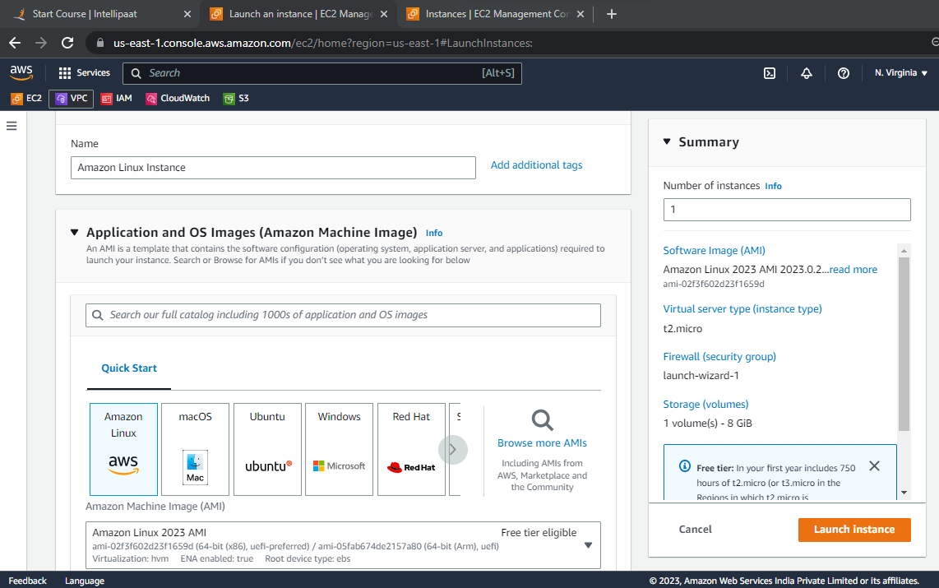

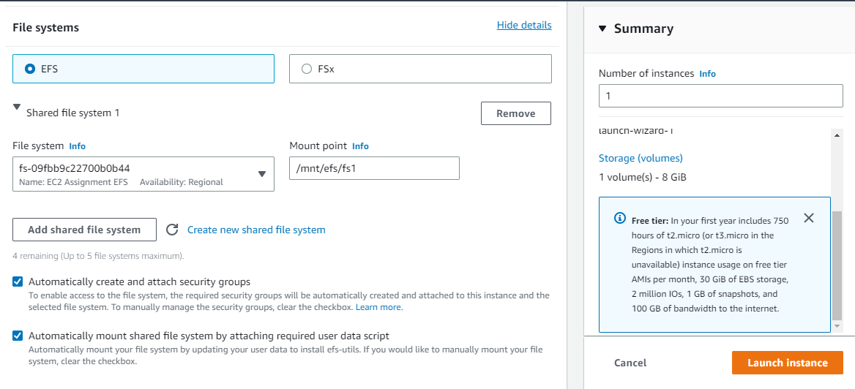

1. Ubuntu Instance

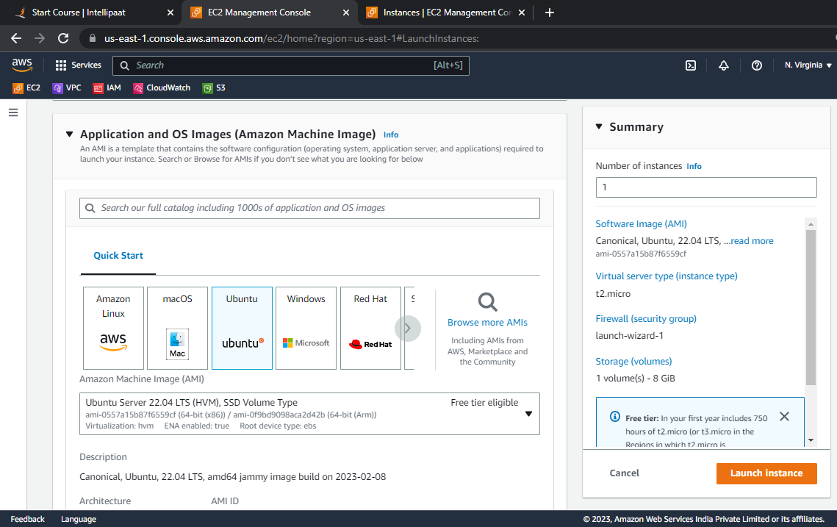

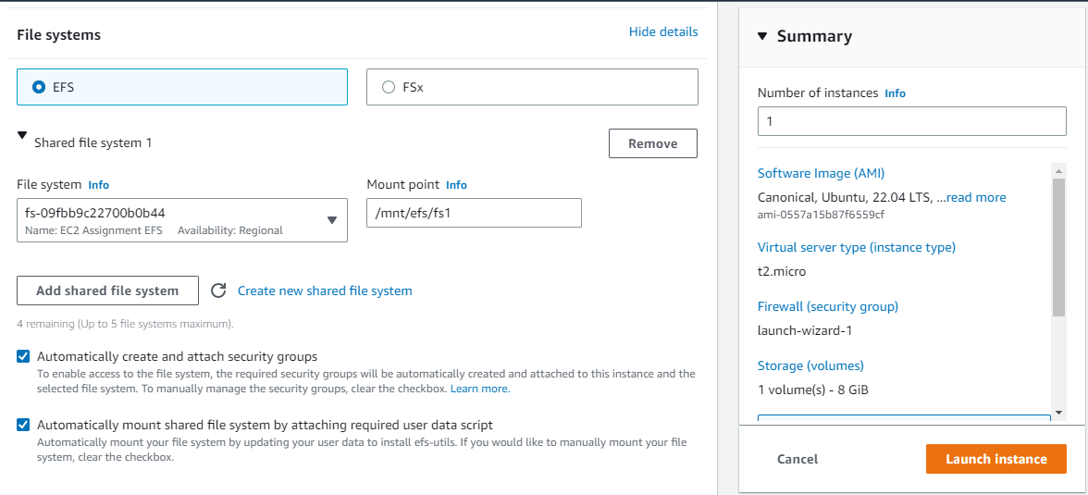

1. Red Hat Instance

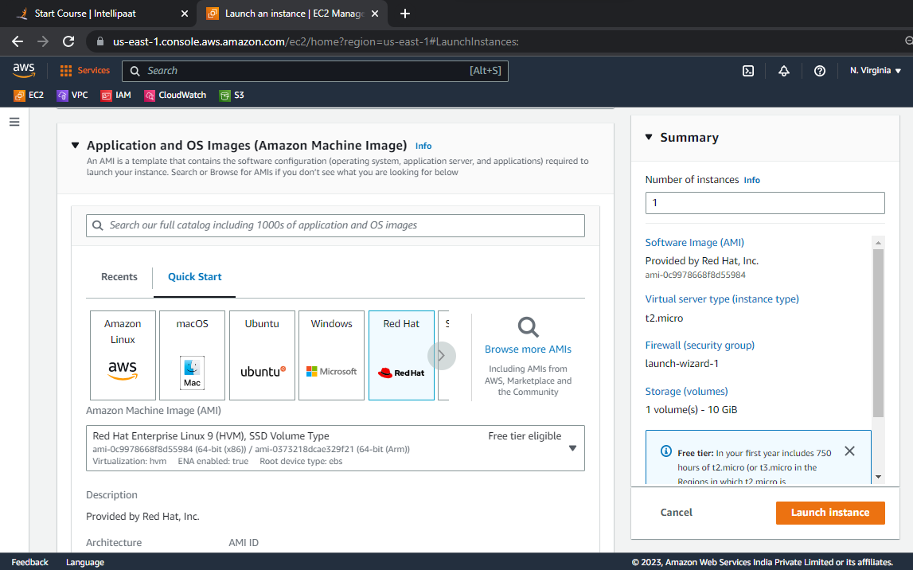

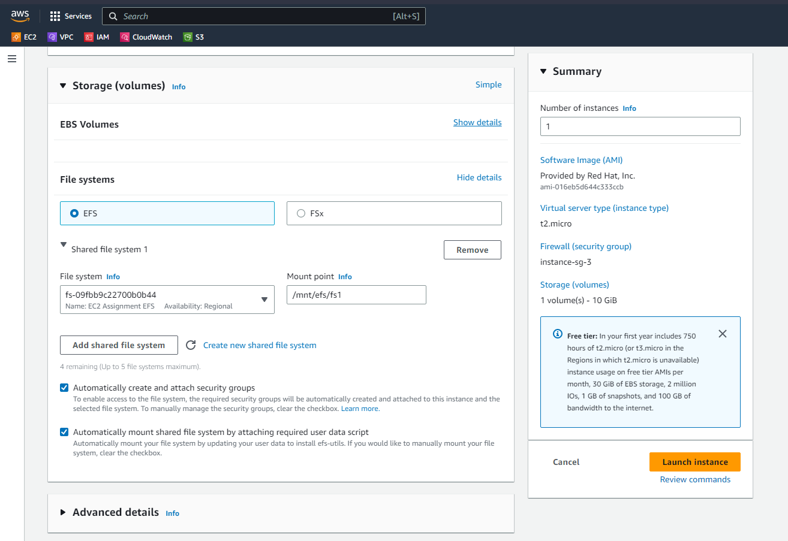

1. Once the EFS have been attached into all the above Instances :
   * 1. Linux Instance : Accessed hello.txt created from RedHat Instance on EFS Mountpoint.

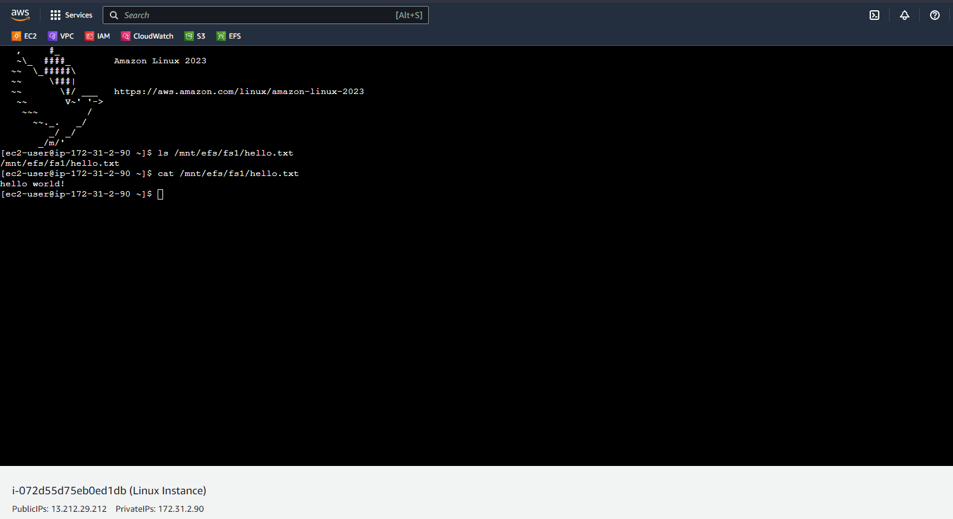

* + 1. Ubuntu Instance : Accessed hello.txt created from RedHat Instance on EFS Mountpoint.

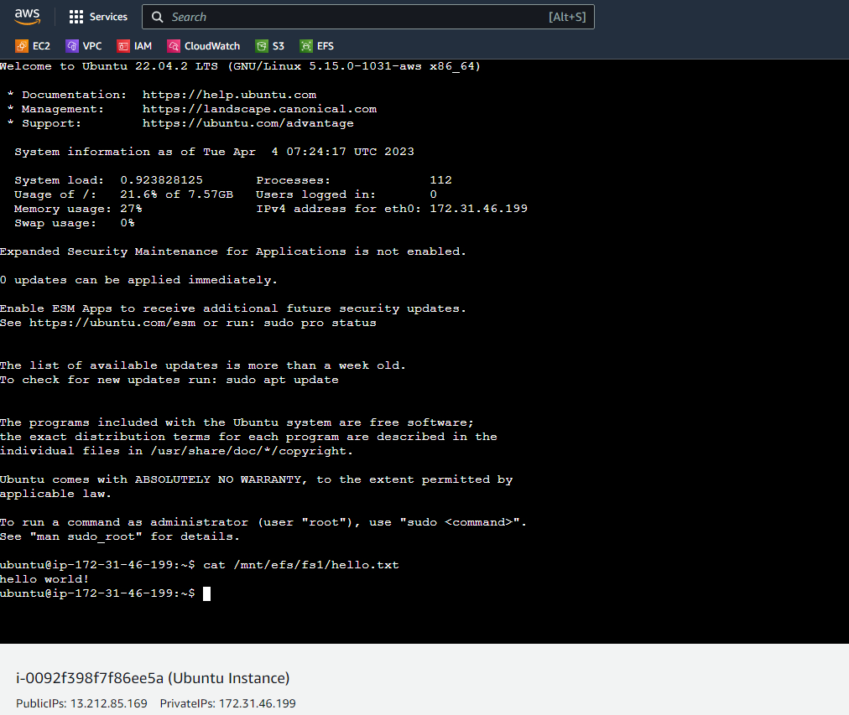

* + 1. RedHat Instance : Created hello.txt File on RedHat Instance on EFS Mountpoint and accessed it over Linux and Ubuntu Instance.

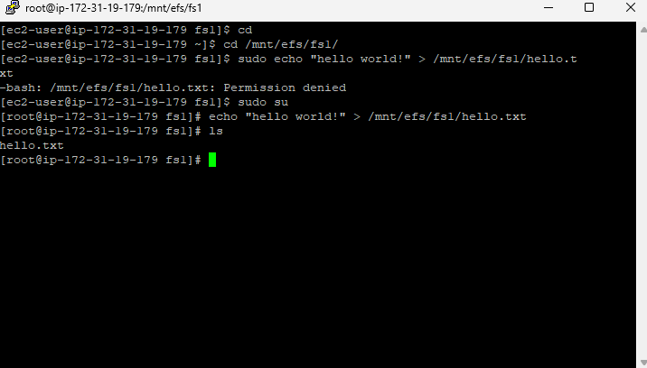

**Module 2 : Case Study**

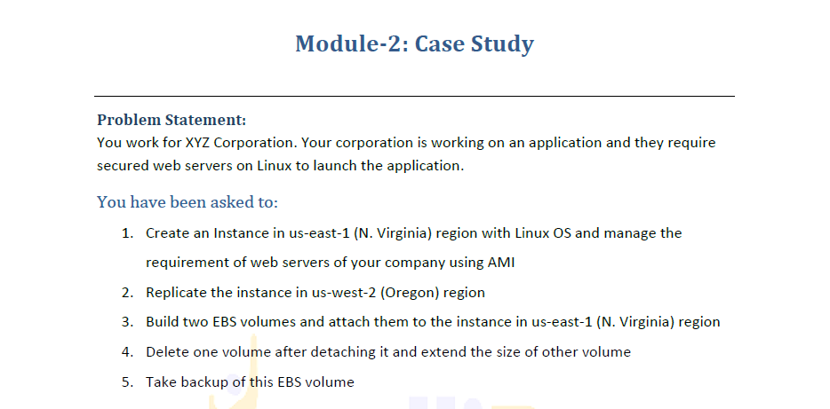

1. Linux Instance created in North Virginia Region.

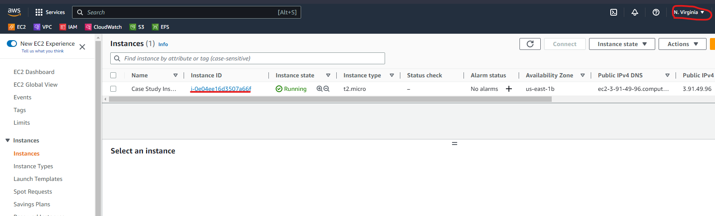

1. Run the below Commands to setup the Web Servers :
   1. sudo yum update : Updates the OS
   2. sudo yum install -y httpd : Installs httpd Server.
   3. sudo service httpd start : Starts https service.
   4. cd /var/www/html : Changes Dir to /var/www/html
   5. sudo nano index.html : Creates Index File to Display.

Index.html File :

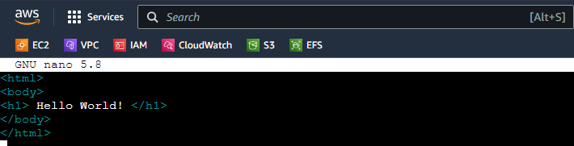

1. Create AMI of the Configured Linux Instances :

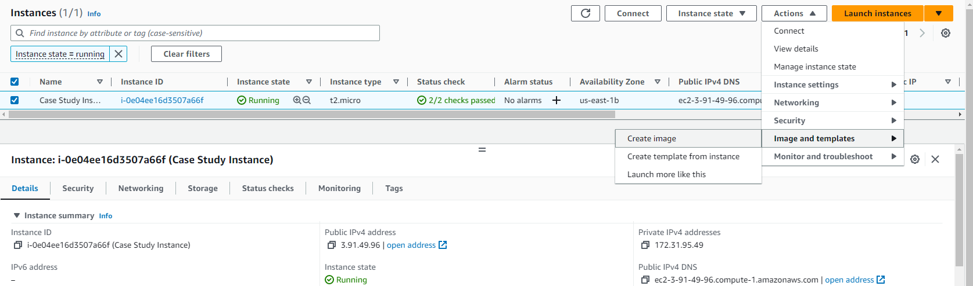

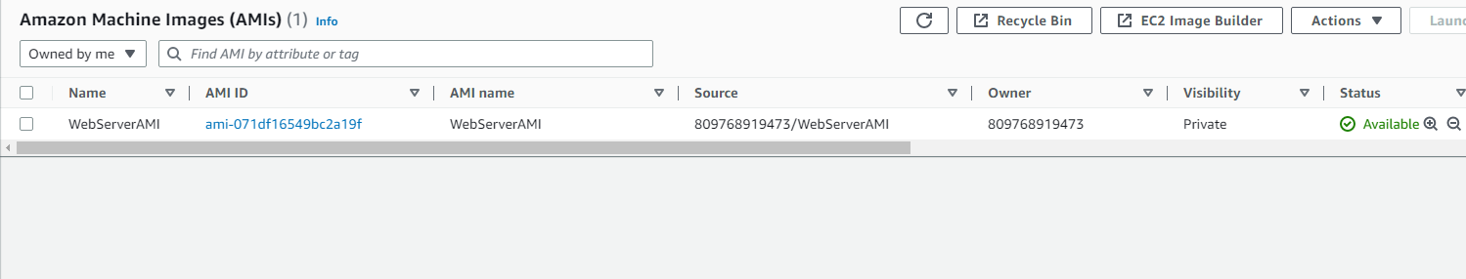

1. Replicated the AMI to Oregon Region.

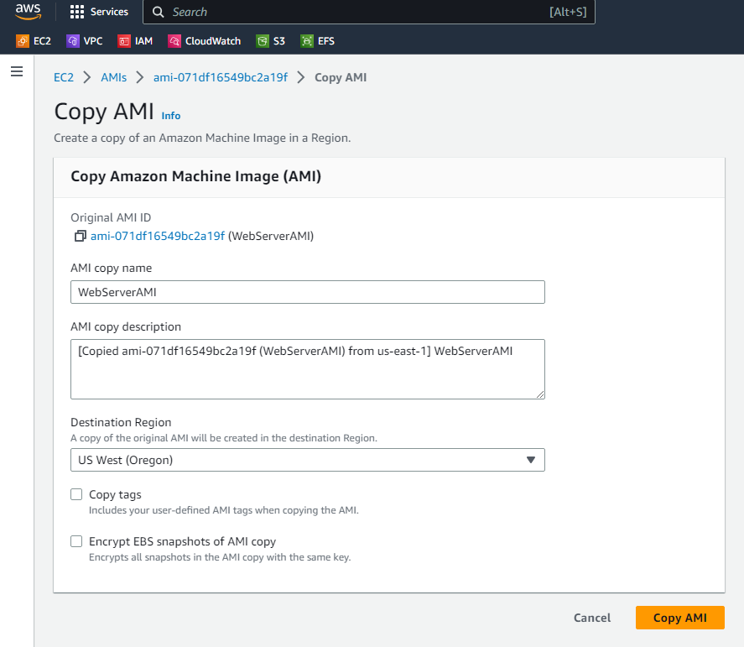

1. Check in Oregon Region for Snapshots

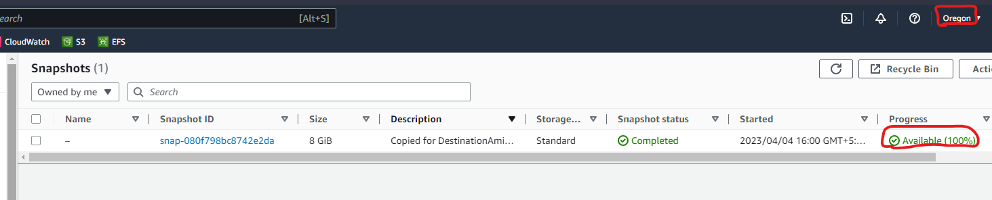

1. Go to My AMIs under Launch Instance > Owned By Me. We will be observing the AMI we Copied from North Virginia to Oregon.

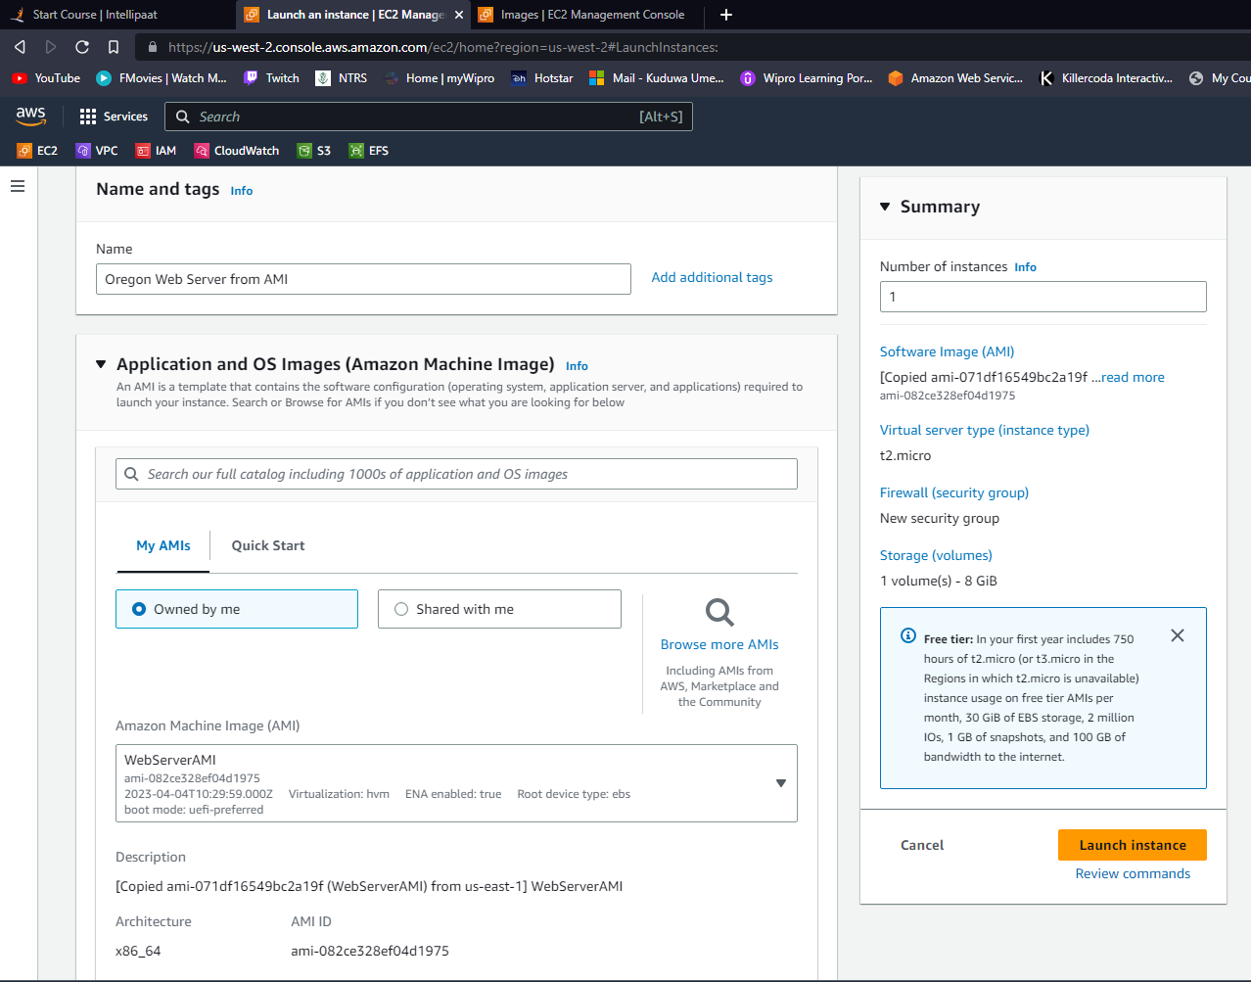

1. User Data Script : sudo service httpd start
2. Once the Instance Launches, directly browse the Public IP.

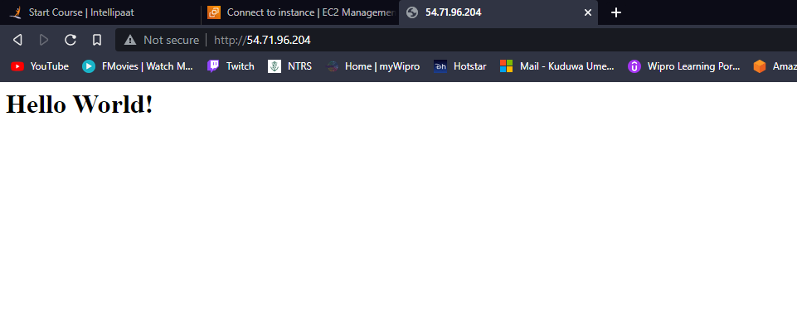

1. Build 2 EBS Volumes in the Same AZ as the Instance.

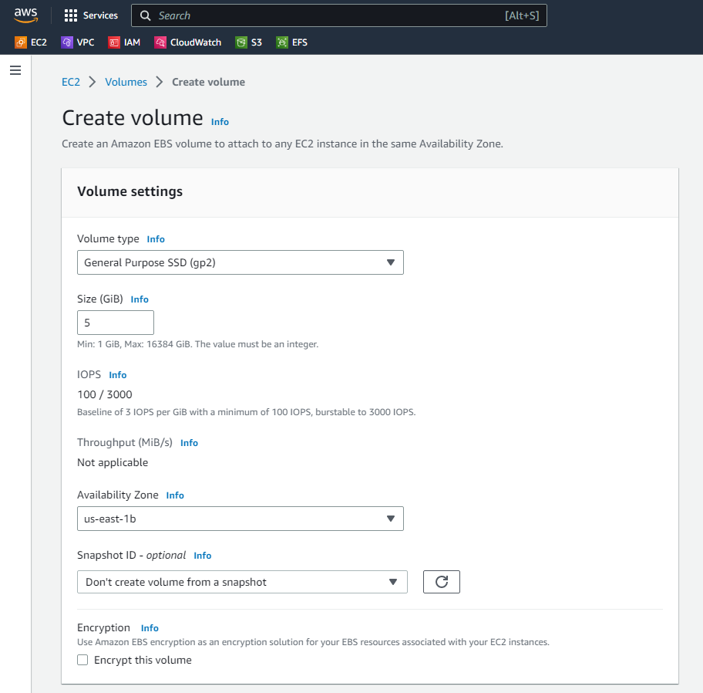

1. Two EBS Volumes of 5 GB Created

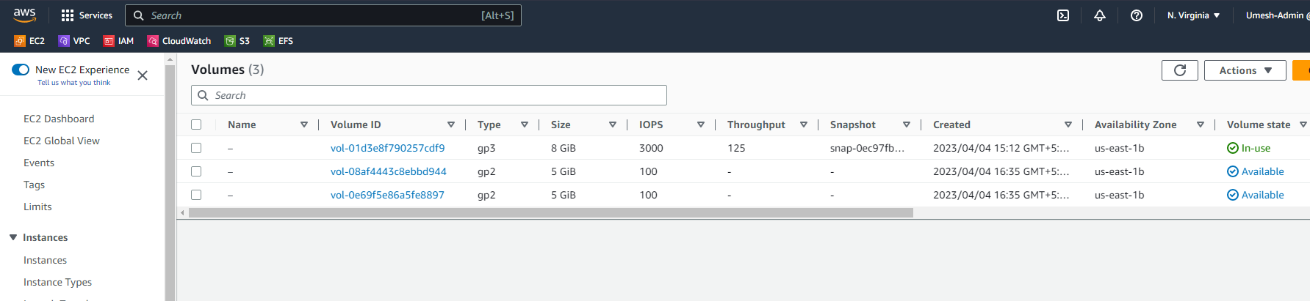

1. Attach the Created Volume into the Linux Instance

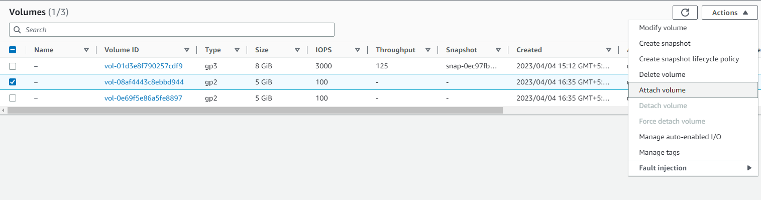

1. Verify / Cross Check if the EBS are Attached to the Instances.

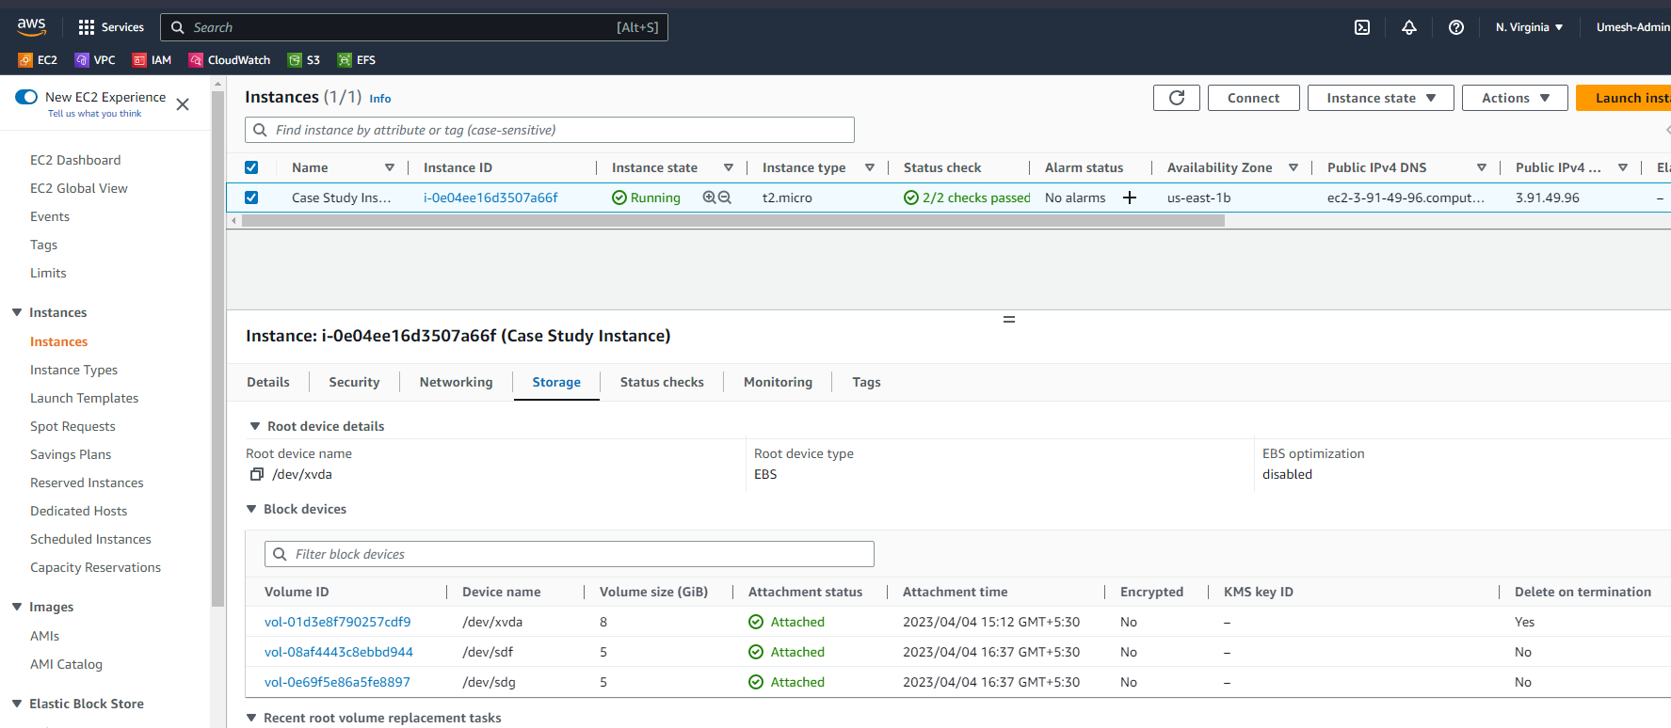

1. Detaching the 3rd EBS Volume.

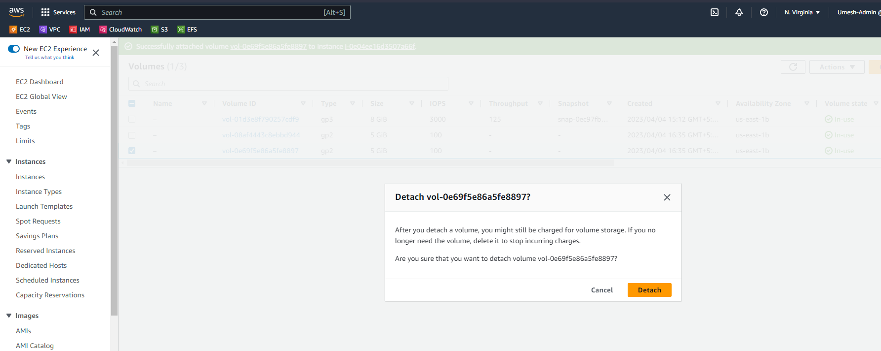

1. Extending the 2nd EBS Volume from 5GB to 10GB.

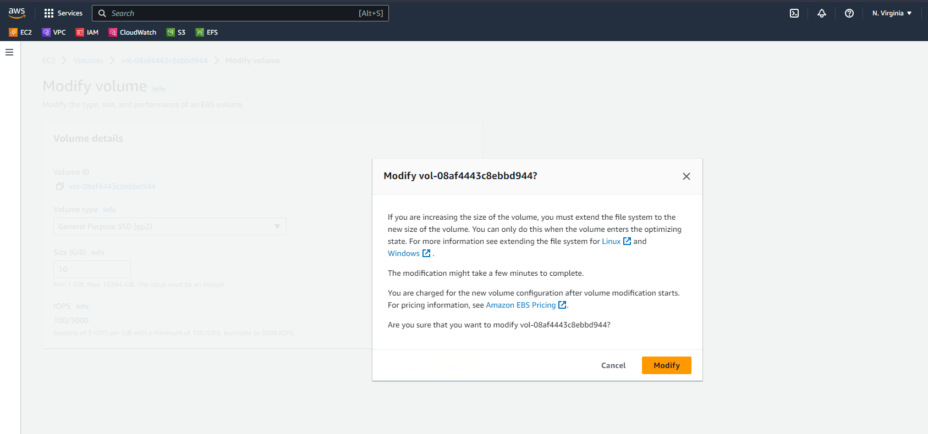

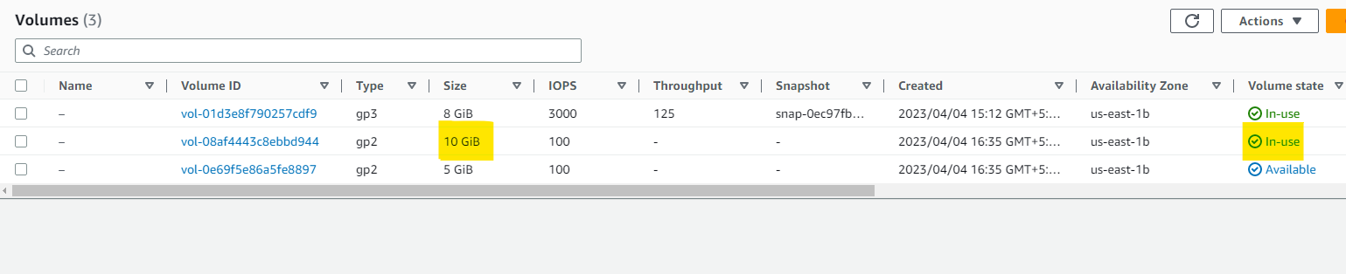

1. Deleted the 3rd EBS Volume after detaching it.

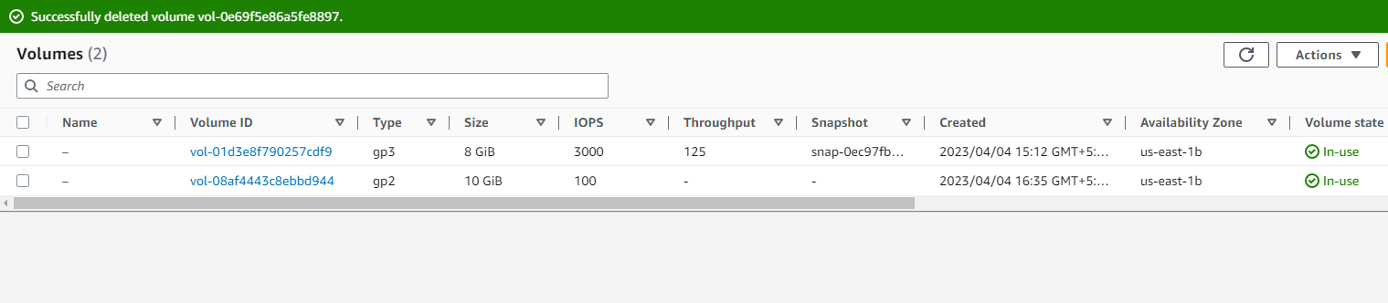

1. Backup of the 10GB EBS Volume.
   1. Click on Actions > Create Snapshot

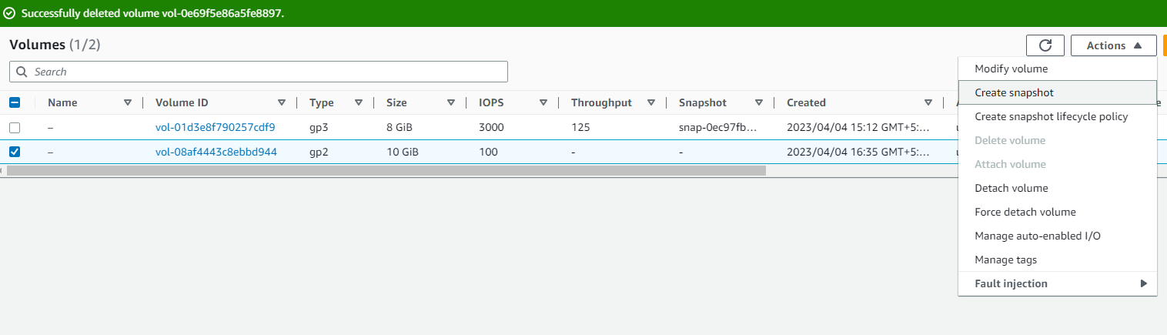

* 1. Go to Snapshot Tab. You will find the 10GB Backup Snapshot of EBS Volume.

